Task 1: Middle of the Linked List
Program :
class Solution {
public ListNode middleNode(ListNode head) {
ListNode slow = head;
ListNode fast = head;

while (fast != null && fast.next != null) {
slow = slow.next;
fast = fast.next.next;
}
return slow;
}
}
Output :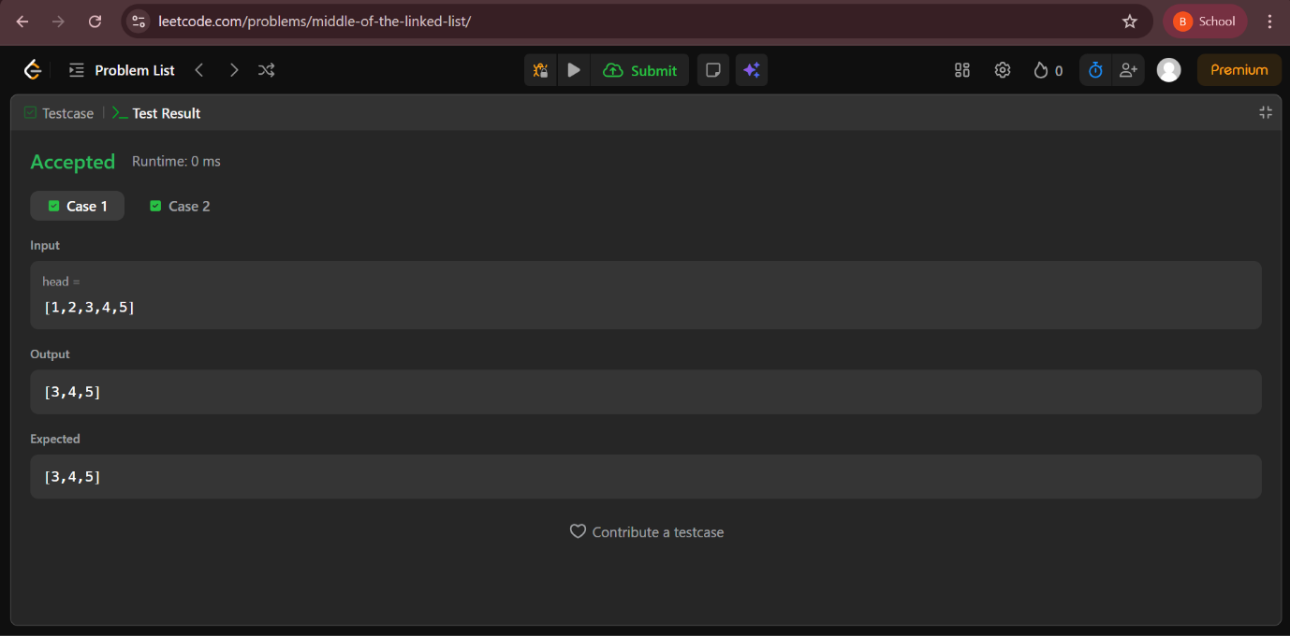
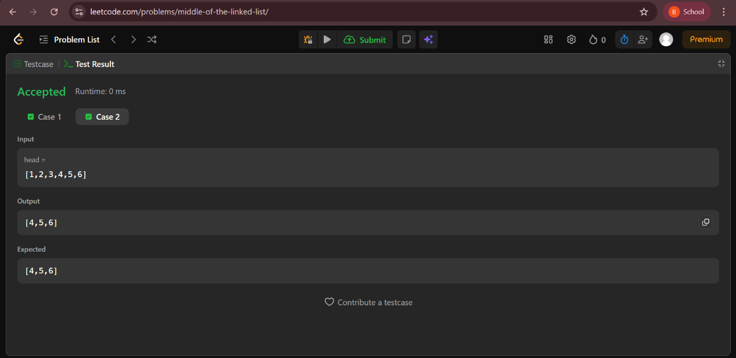

Task 2: Palindrome Linked List
Program :
class Solution {
public boolean isPalindrome(ListNode head) {
if (head == null || head.next == null) return true;
ListNode slow = head, fast = head;
while (fast != null && fast.next != null) {
slow = slow.next;
fast = fast.next.next;
}
ListNode second = reverse(slow);
ListNode first = head;
while (second != null) {
if (first.val != second.val) return false;
first = first.next;
second = second.next;
}
return true;
}
private ListNode reverse(ListNode head) {
ListNode prev = null;
while (head != null) {
ListNode next = head.next;
head.next = prev;
prev = head;
head = next;
}
return prev;
}
}
Output :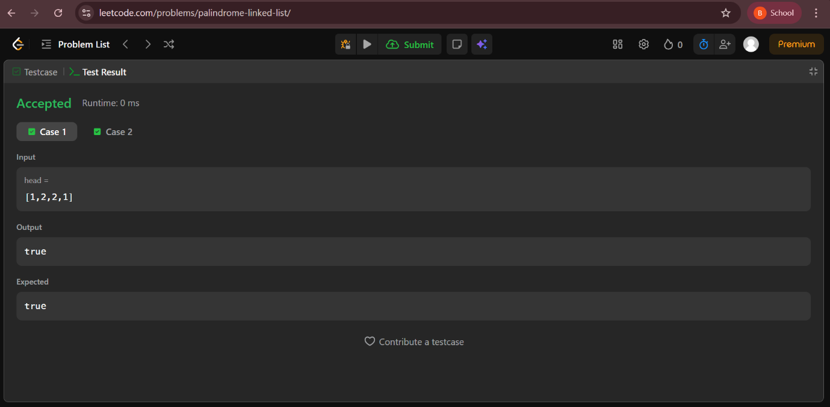

Task 3: Merge Two Sorted Lists
Program :
class Solution {
public ListNode mergeTwoLists(ListNode list1, ListNode list2) {
ListNode dummy = new ListNode(-1);
ListNode cur = dummy;
while (list1 != null && list2 != null) {
if (list1.val <= list2.val) {
cur.next = list1;
list1 = list1.next;
} else {
cur.next = list2;
list2 = list2.next;
}
cur = cur.next;
}
cur.next = (list1 != null) ? list1 : list2;
return dummy.next;
}
}
Output :
Task 4: Merge k Sorted Lists
Program :
import java.util.PriorityQueue;
class Solution {
public ListNode mergeKLists(ListNode[] lists) {
if (lists == null || lists.length == 0) return null;
PriorityQueue<ListNode> pq =
new PriorityQueue<>((a, b) -> a.val - b.val);
for (ListNode node : lists)
if (node != null) pq.offer(node);
ListNode dummy = new ListNode(-1);
ListNode cur = dummy;
while (!pq.isEmpty()) {
ListNode node = pq.poll();
cur.next = node;
cur = cur.next;
if (node.next != null) pq.offer(node.next);
}
return dummy.next;
}
}
Output :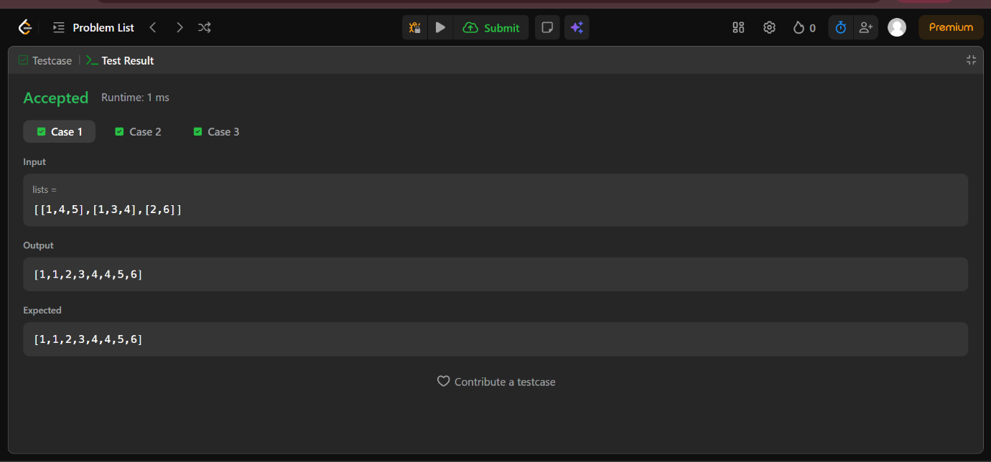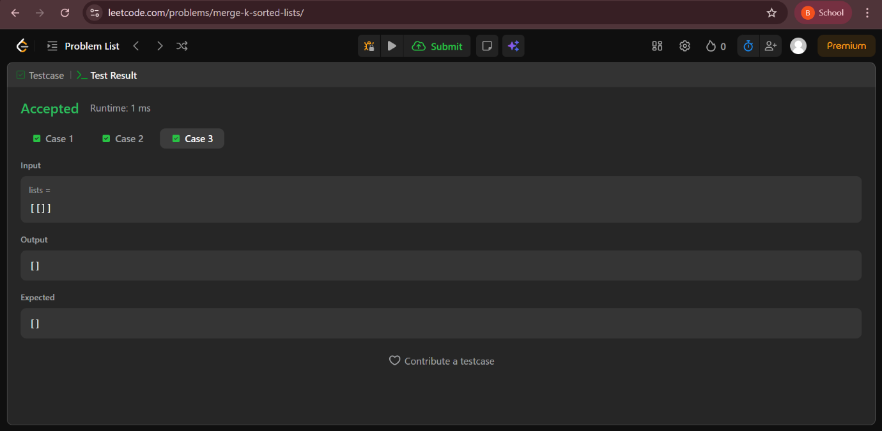

Task 5: Reverse Linked List
Program :
class Solution {
public ListNode reverseList(ListNode head) {
ListNode prev = null;
ListNode curr = head;
while (curr != null) {
ListNode next = curr.next;
curr.next = prev;
prev = curr;
curr = next;
}
return prev;
}
}
Output :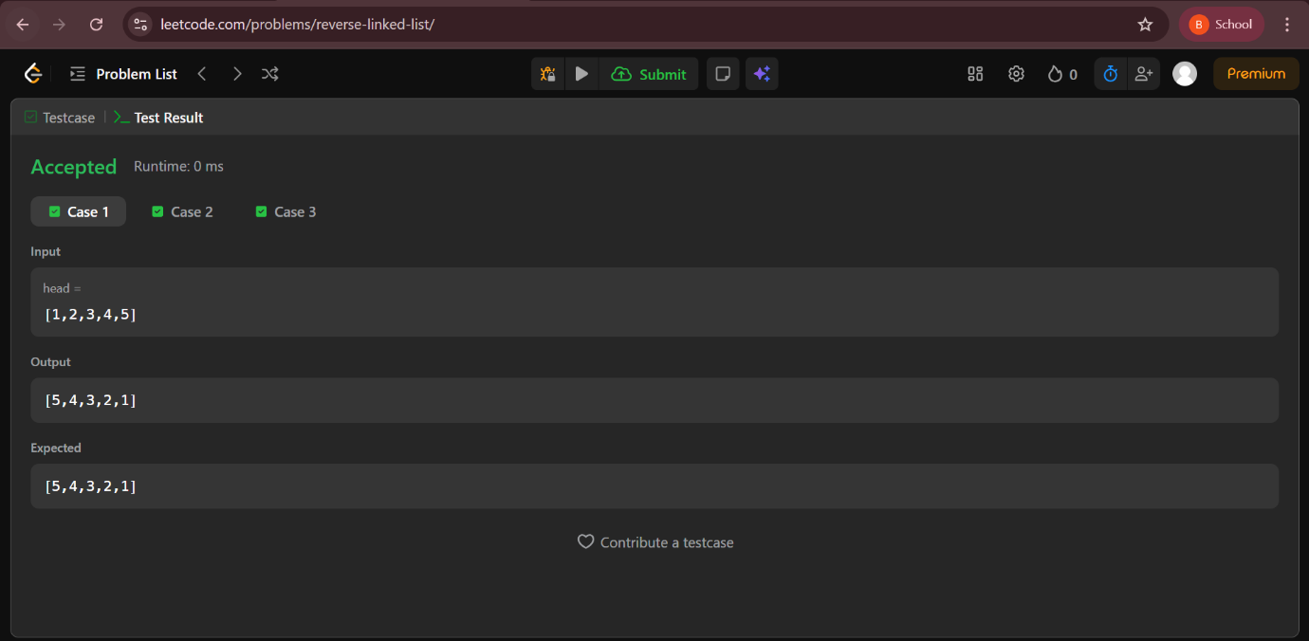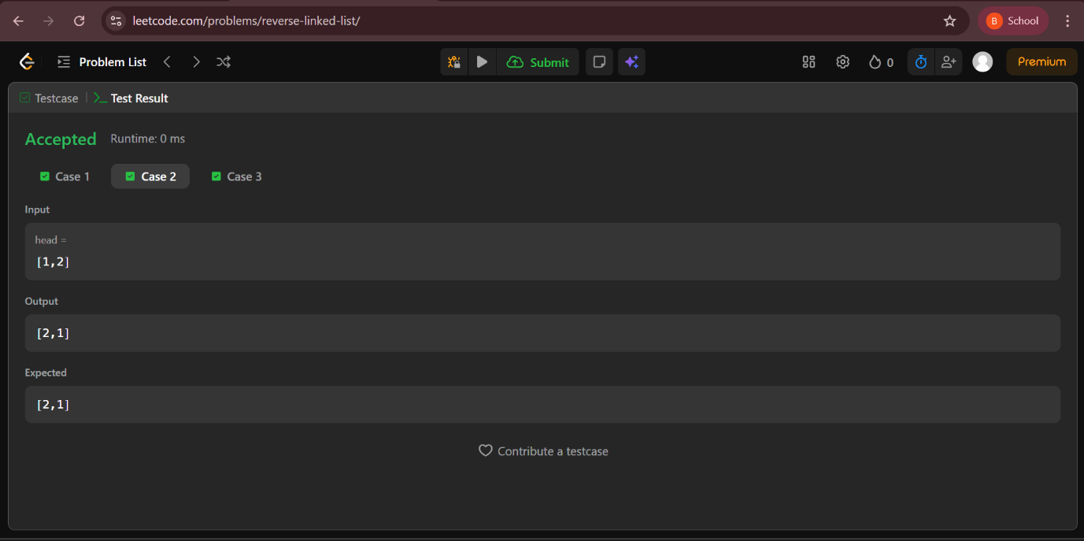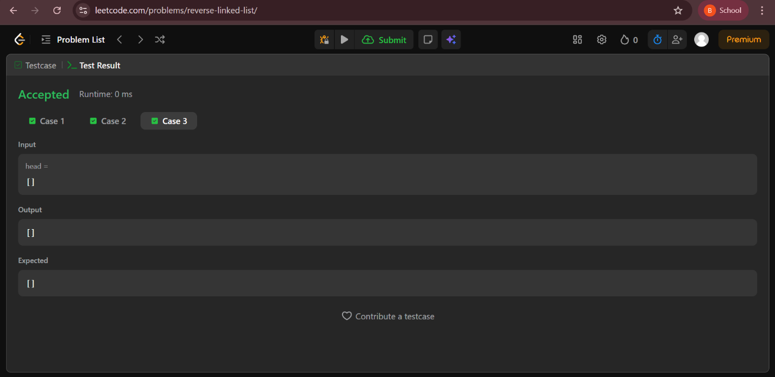

Task 6: Reverse Nodes in k-Group
Program :
class Solution {
public ListNode reverseKGroup(ListNode head, int k) {
if (head == null || k == 1) return head;
ListNode dummy = new ListNode(0);
dummy.next = head;
ListNode groupPrev = dummy;
while (true) {
ListNode kth = getKth(groupPrev, k);
if (kth == null) break;
ListNode groupNext = kth.next;
ListNode prev = groupNext;
ListNode curr = groupPrev.next;
while (curr != groupNext) {
ListNode temp = curr.next;
curr.next = prev;
prev = curr;
curr = temp;
}
ListNode temp = groupPrev.next;
groupPrev.next = kth;
groupPrev = temp;
}
return dummy.next;
}
private ListNode getKth(ListNode curr, int k) {
while (curr != null && k > 0) {
curr = curr.next;
k--;
}
return curr;
}
}
Output :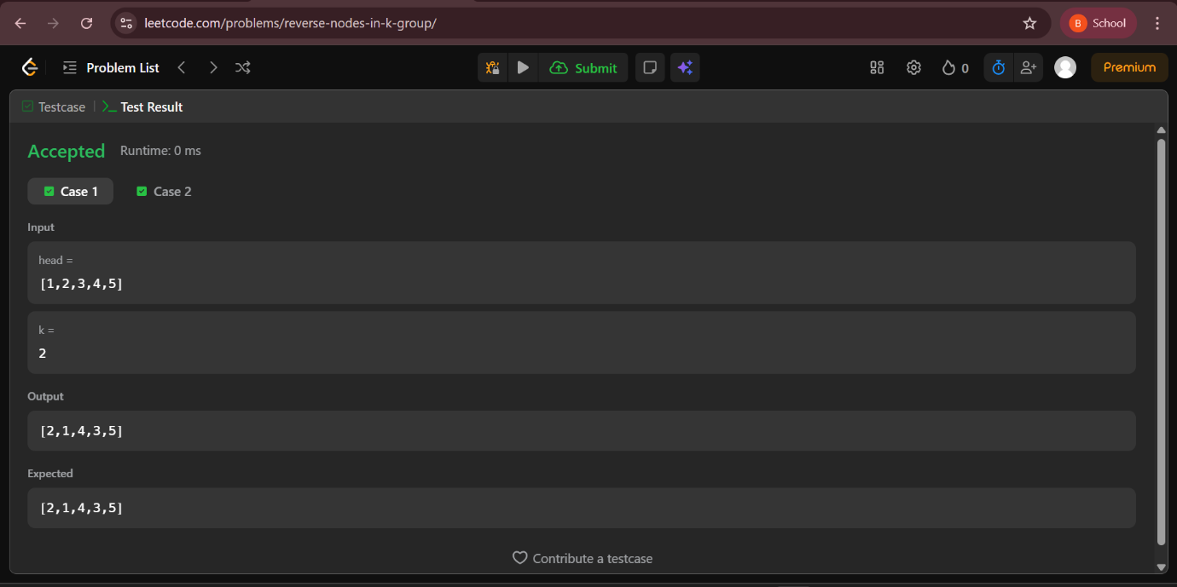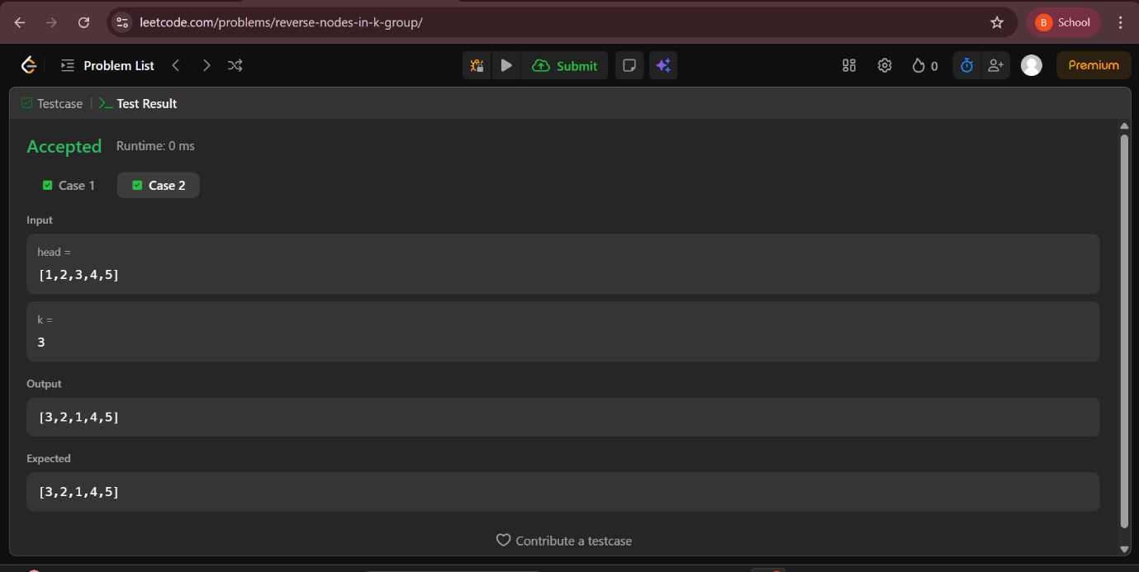

Task 7: Linked List Cycle II
Program :
public class Solution {
public ListNode detectCycle(ListNode head) {
if (head == null || head.next == null) return null;
ListNode slow = head, fast = head;
while (fast != null && fast.next != null) {
slow = slow.next;
fast = fast.next.next;
if (slow == fast) {
ListNode entry = head;
while (entry != slow) {
entry = entry.next;
slow = slow.next;
}
return entry;
}
}
return null;
}
}
Output 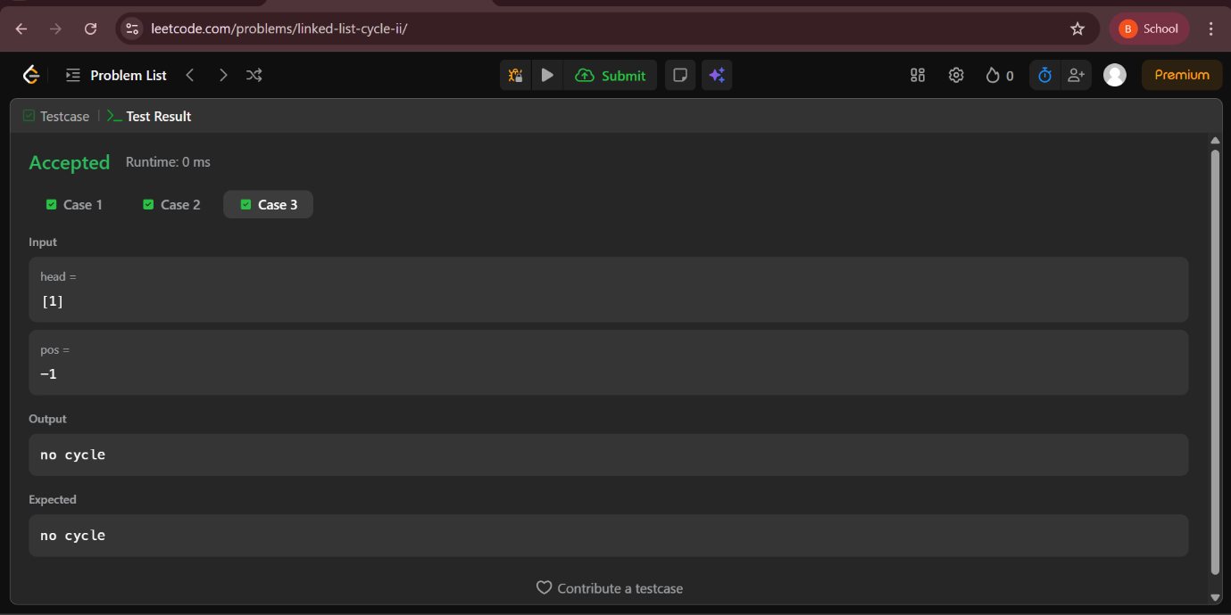

Task 8: Intersection of Two Linked Lists
Program :
public class Solution {
public ListNode getIntersectionNode(ListNode headA, ListNode headB) {
if (headA == null || headB == null) return null;
ListNode a = headA;
ListNode b = headB;
while (a != b) {
a = (a == null) ? headB : a.next;
b = (b == null) ? headA : b.next;
}
return a;
}
}
Output :

